Bureau Des Infractions Provinciales
141 Rue Lakee
Pembroke, ON K8A 5L8
Téléphone: 613-735-3482
Facsimile: 613-735-8484
www.countyofrenfrew.on.ca

Provincial Offences Office
141 Lake Street
Pembroke, ON K8A 5L8
Phone: 613-735-3482
Fax: 613-735-8484
www.countyofrenfrew.on.ca
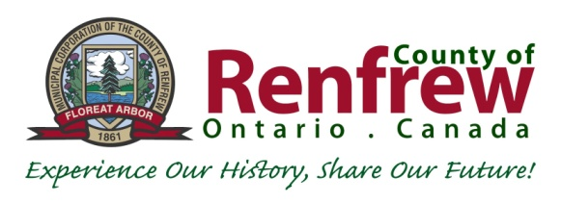

PAYMENT AGREEMENT
I, agree to make payments in the amount of $ per month
(Name – Please Print) ($ Amount)

(amount subject to an annual review) beginning on the day of ,20___
(Day of month) (Month) (Year)

until all fines in the amount of $ are paid in full to the County of Renfrew,
(Total $ Amount Owing)
Provincial Offences Court.

Please Note: If using preauthorized debit, payments are only processed on the 1st or 20th of the month.
If the terms of this agreement are not met I understand that, with no further notice to me, this office will take further enforcement measures including action by a Collection Agency which will affect my personal credit rating, further court action resulting in civil enforcement and/or license suspension/ plate denial.
I also understand that any convictions registered against me after the date of this agreement are NOT
part of this payment agreement.
Dated this day of 20 .
(Day of the Month) (Month) (Year)
Signature:
Mailing Address:
Email Address:
Cell # / Telephone #:
Occupation/Place of Work:

